**Activity 8**

**The Human Knot**

[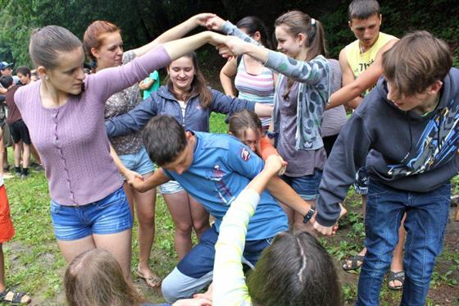](http://icebreakerideas.com/wp-content/uploads/2015/11/Notes-for-Human-Knot-Game-Facilitators-e1447920953666.jpg)

Nothing promotes cooperation like getting all tangled up with your classmates … literally! Students will start in a circle and join each hand with a different person, the whole group ending up in a twisted mess. The fun begins when they start to negotiate escaping the tangle without letting go of one another’s hands—it will definitely take working together.

**SKILLS:**

Teamwork, communication, problem-solving

**HOW TO:**

To play, players stand in a circle and reach out to shake hands with other players, with each hand connecting to a different person, creating a “human knot.” Then the players have to figure out how to unthread their bodies without letting go of each other’s hands.

Follow up discussion - Who cooperated and what strategies worked best?