**Activity 3**

**No-Hands Cup-Stacking Challenge**

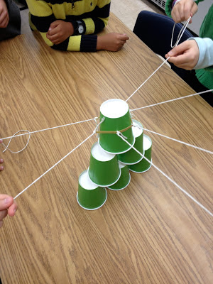

This hands-on group challenge is an exercise in patience and perseverance, not to mention a total blast! Using only strings and a rubber band, students must work together as a team to build a pyramid of paper cups. You’ll be surprised at the amount of trial and error your teenagers will need before they get the hang of this activity.

**SKILLS:**

Critical-thinking and problem-solving skills, teamwork, patience

**HOW TO:**

Decide how many students you want in each group. Tie that many strings to a single rubber band. Each person in the group holds on to one of the strings that is attached to the rubber band, and as a group, they use this device to pick up the cups (by pulling the rubber band apart and then bringing it back together over the cups) and place them on top of each other in order to build a pyramid.

**FOLLOW UP QUESTIONS:**

* Was anyone frustrated at all during the activity? If so how was it handled?
* What did you learn about yourself or others?
* Why was teamwork so important for this activity?
* What is so hard about teamwork?
* What did you do today to contribute to the teamwork on your team?
* What are some skills needed to be good at teamwork?
* Are you every in a situation where you must use teamwork? Is this always easy for you? Why or why not?
* How can we use what we learned through this experience in situations outside the game?