Attachment 1- Anticipation Guide: Advanced Manufacturing
Read each of the following statements. Then decide how strongly you agree or disagree with each.
After learning about manufacturing, look back at your ratings. Discuss how your thinking has changed or been confirmed on one or more of the statements.

Statement | Before |  | After
 | Agree | Disagree | Agree | Disagree
Everything you touch has been manufactured.
Manufacturing requires high- tech solutions and a highly skilled and qualified work force
The manufacturing marketplace consists only of human-run assembly lines.
Manufacturers work in dark factories.
When I think of manufacturing
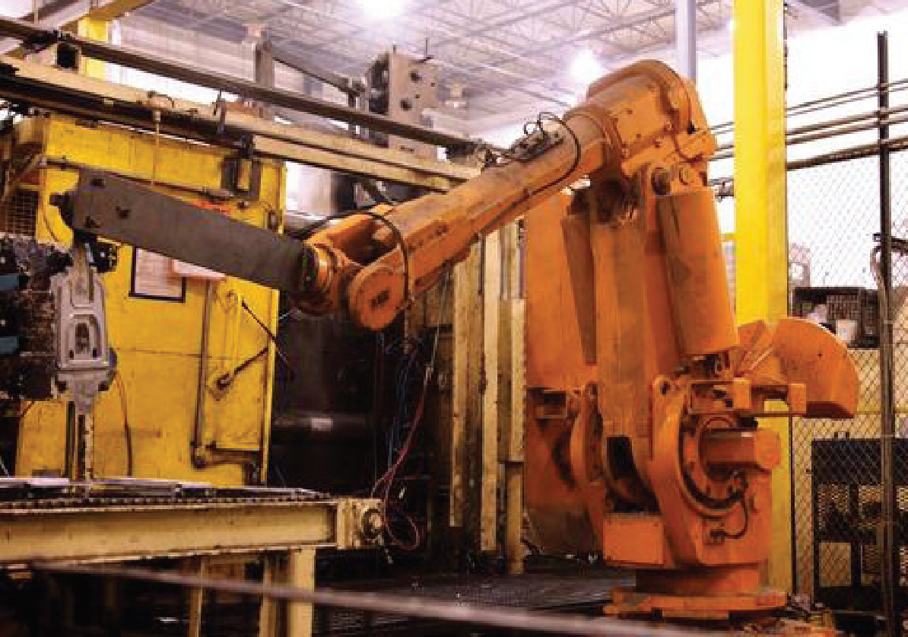
it looks like this:

Manufacturers work with robots to build products together.
I would be interested in pursuing a career in advanced manufacturing.

