2020-21 Flex PBL

| PBL Title: | Dynamic Digital Profile with *Tallo* |  |  |
| --- | --- | --- | --- |
| Duration: | 4 weeks | Release Date: | August 31, 2020 |
| HELP? | e-mail jenn.beal@jag.org | Pages: | 12 |

Project Summary

This Flex PBL is intended to be one of the first projects student engage with as they return to school for the 2020-2021 academic year.

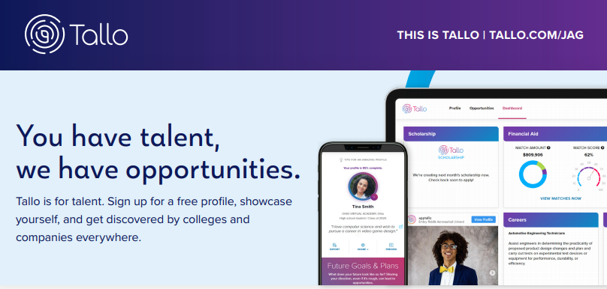The overall goals of the project are to have students:

1. identify their strengths,
2. showcase their abilities through a online platform, and
3. get discovered by colleges and companies everywhere.

*Tallo* is a free and safe online platform and app that has partnered with JAG students across the country to connect talent with opportunities. *Tallo* assists students in designing a career pathway, educators in recruiting top talent for their schools, and employers in developing a stable, continuous talent pipeline. Students (age 13+) and professionals showcase their skills and abilities in their online profile in order to be connected directly with companies and colleges looking for the next generation of talent, as well as match with over $20 billion in scholarships.

Competency Attainment

**Level 1:** A.3-Identify desired life style and relate to selected occupation, A.4-Develop a career path for a selected occupation, B.12-Complete employment tests, D.23-Communicate in writing,

**Level 2:** A.1-Identify occupational interest, aptitudes and abilities, A.2-Relate interests, aptitudes and abilities to appropriate occupations, A.5-Select an immediate job goal, C.18-Follow directions, D. 22-Comprehend written communications, E.26-Demonstrate team membership,

**Level 3:**

JAG Competencies should be set based on the Specialists discretion.

The above stated are merely suggestions based on the project structure.

Notes for Specialist

* This Flex PBL was designed with two intended purposes:
  1. to meet the ever-changing instructional needs of JAG Specialists across the JAG National network and
  2. to provide relief with competency attainment and project design to allow Specialists the space to devote a majority of their time in meeting the immediate needs of students.
* A Flex PBL can be administered in a variety of instructional modalities. Here are three of the most common options:
  + **Traditional; full time, in-person instruction** – walk through the steps in showing videos and leading discussions as a typical class unit.
  + **Hybrid, blended or a flipped classroom** – identify and pull out the pieces that can be asked of students to perform outside of in-person class time (i.e. to watch videos, journal, etc.) and reserve team building, discussions and/or problem solving for in-person opportunities.
  + **Completely online model** – this Flex PBL can also be administered in a completely online format, by using any means of delivery that is being directed or offered by your school district.
* The format of this Flex PBL was aimed to be easily manipulated for Specialists to deliver the project within a classroom. They can print, copy and paste into an e-mail, text, social media or a learning management system (i.e. Google Classroom, Canvas, etc).
* The intentional design of this Flex PBL is to allow a logical and manageable flow for students to work in a self-guided way.
* A series of webinars are available on the Genius for each of these three options. The topic area shifts from week to week, but the three group offerings remain consistent to accommodate your needs as they may change throughout the 2020-2021 academic year.
* In addition to Genius resources, the JAG National Staff is available for steps on the practical application of this Flex PBL.
* 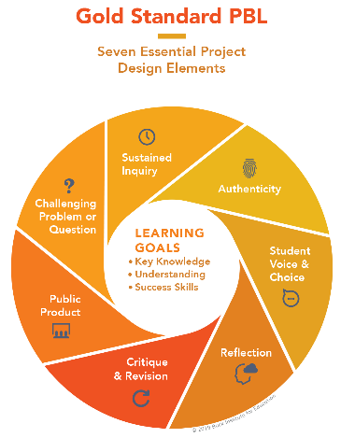The yellow highlighted sections need Specialist attention, as they are notes that require an action of the Specialist.
* Remember that each student responsibility can be adjusted to fit the needs of your students, especially when it comes to the expected time spent on this project. **You are encouraged to add, remove or change out any elements within this Flex PBL to make this project suitable for your JAG students**. Just remembering that a strong PBL (regardless of delivery method) has seven essential gold standard elements.
* Please complete this **JAG** **Specialist** survey at the completion of the project: <https://forms.gle/mzg5zbVisNyYYta37>
* Finally, Specialists are responsible for how grading/allocation of points are determined based on your program expectations.

Flex PBL – Dynamic Digital Profile with *Tallo*

**Driving Question**

How can I best showcase my talents, skills, experience and personality while also getting connected with opportunities specific to my goals through a digital profile on *Tallo*?

**Entry Event**

Launch this project by connecting with *Tallo* on social media. Check out the student testimonials and other valuable information that highlights the platform’s success! **@*Tallo*App**

After reviewing one of the four social media outlets for *Tallo*, have students check out the two following experiences to help prepare them for the upcoming project:

* Watch the “Hamilton” cast find out which Disney/Hamilton Character Combo they are. <https://www.youtube.com/watch?v=vHHHM7CXWGE>
* Practice taking a survey by clicking on this link and sharing information All About You! 😊 <https://forms.gle/D5bQwaW4pNusiL7D8>

Share with students that they will have opportunities to learn more about themselves in silly ways as well as in valuable ways that connect to their career. Also express to students the importance to completing surveys to aid others in learning more about them by sharing their interests and ideas. Allow for dialogue and further discussion.

Then, ask for students to come up with their own version of a personality quiz that has 3-5 questions using Google Forms. Similar to the example from the “Hamilton” video and using their experience taking the “All About Me” survey, students can be creative in developing a silly or serious quiz using an online form through Google. Here is a link for help: <https://support.google.com/docs/answer/6281888?co=GENIE.Platform%3DDesktop&hl=en>

If students wish, they can share their personality quiz via social media by tagging @GeniusJAG on Twitter and/or Instagram with a post sharing their survey link. You may also consider having students share through a local or private social media page for your school or program.

**Public Product**

At the end of this project, students will have a digital profile using *Tallo* and an understanding of how to utilize a digital platform to showcase skills and interests as well as get connected with opportunities. Students will be given time and the tools to create and develop a dynamic digital profile through this project. The key will be how they choose to use *Tallo* beyond this project.

Students will put together a way to express to others how 1) they created a dynamic digital profile as well as how they plan to maintain/update their profile and 2) assist others with how they might do the same. The mode of delivery is up to the student or group of students (verbal presentation, written communication and/or a visual representation).

Here is a rubric to help guide student’s work on this Flex PBLs Public Product: (insert link, picture or attachment) A *PBLWorks* rubric link is provided below as an example. Adjustments can and should be made to fit the delivery method you or the students select for this Public Product.<https://my.pblworks.org/resource/document/9_12_presentation_rubric_non_ccss?_ga=2.202124241.1541406188.1596114595-70278534.1592403584>

Week 1 of 4

JAG Student Week One Responsibilities

* Specialist will record and share a link here or do an in-person overview of the importance of a high-quality online profile for students. JAG Specialists can share information about LinkedIn and/or other valuable resources; however should focus on *Tallo* for the purposes of this project. Express how *Tallo* is a FREE online platform offered to all JAG students through a National partnership. In addition, specifically for this Flex PBL—*Tallo* and JAG are offering four $250 eGift Cards to Amazon for students who create a new or update an insisting profile between Sept. 1-Oct. 15, 2020. (Approx. 5 minutes)
* Read this article: 7 Reasons You Need A Vibrant Digital Profile (4 minutes)

<https://www.forbes.com/sites/85broads/2012/11/30/7-reasons-you-need-a-vibrant-digital-profile/#385bf6943a72>

* Take a moment to consider what you know about professional online profiles, if anything. It is important to know that social media accounts are separate from a professional online profile that individuals created on LinkedIn. Ask yourself: why would it be important for me to have a professional online profile? If you are struggling with how to answer this question, do some Google searching to explore reasons why this concept is valuable to students and specifically for you and your desired future. (20 minutes)
* Watch this video: The Importance of a Professional Email Address for Jobs (3 minutes)

<https://www.youtube.com/watch?v=HV4K95wFkNo>

* Send an e-mail to your JAG Specialists from a non-school e-mail address. (2-5 minutes)
* To: (insert Specialist work/school e-mail address)
* Subject: E-mail Test
* E-mail Content: Hello--This is (insert your first and last name) and I am testing my professional e-mail. Would you please reply to this message with your assessment of my e-mail address and its readiness for use? Thank you!

**If you do not have a personal e-mail that is professional, create a FREE one by going to: <https://accounts.google.com/signup/v2/webcreateaccount?flowName=GlifWebSignIn&flowEntry=SignUp>

* + 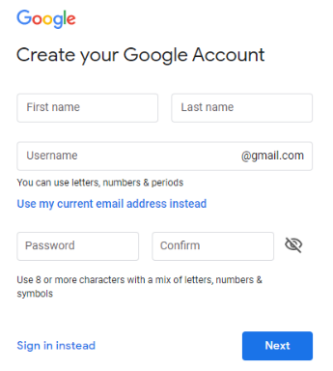When you arrive on the page that looks like what you see to the right, you will enter your first name, last name and create a unique username for your new Gmail account. Gmail was selected as the preferred e-mail provider, because of its connections to the *Tallo* platform and various other Google-related products that are helpful for students and young professionals.
  + Please reach out to your JAG Specialist if you need help in creating an appropriate e-mail address.
  + Also, be sure to save your password in a safe spot!
* Watch this video: *Tallo* overview (1 minute)

<https://www.youtube.com/watch?v=awfz4FjB9GU>

* When ready to join *Tallo*, follow these easy steps: (2 minutes)
  + Go to *Tallo*.com/jag and click “Get Started”. If you already have a *Tallo* profile, do not create a new account; rather log into your existing account and update your e-mail address if necessary.
  + Brag a little! Fill out some basic profile info, like your school and verify your e-mail address.
  + In your profile, click the “edit” button in the Badges section and request the **JAG 2020-2021 Membership** badge.



Remember: all JAG student who requests the

2020-2021 membership badge between

September 1-October 15, 2020

will be entered into a drawing for one of four

$250 eGift Cards to Amazon

for any back-to-school supplies you may need!

* Explore *Tallo*
* Watch this *Tallo* How To video of Dashboard Tools to Connect with Opportunities: <https://www.youtube.com/watch?time_continue=62&v=2iND6uvLjBQ&feature=emb_logo>

(3 minutes)

* Spend some time exploring (7 minutes)
  + What does this mean “explore”? Do some clicking around and trying things within the platform. Don’t worry—you won’t break anything! 😊
* At this point, check-in with your Specialist. The indicator word is purple. (2-5 minutes)
* Share any challenges you may be having with the *Tallo* website and/or your profile creation. This would be a great opportunity to check with your Specialist to make sure you have correctly added the “JAG 2020-2021 Membership” badge, so you can be entered into the drawing!
* Specialist will record and share a link here or lead an in-person discussion on the importance of taking opportunities as they present themselves. It may not seem important at this specific time within the school year to be creating a professional online profile; however, express the key pieces that can be added to this profile throughout the year as they are a member of JAG and are able to participate in various leadership and skill developments. It would not hurt to remind students of the prizes made available specific to JAG students who take the time to 1) create and profile on *Tallo* and 2) add the current year JAG membership badge. By doing these two steps, students have the potential of winning one of four $250 eGift Cards to Amazon. This could go a long way for school supplies like high-quality head phones or necessary technology during this school year.

Week 2 of 4

JAG Student Week Two Responsibilities

* Specialist will pose a question to all students that asks them to post to an online discussion board or poll question. The key is that each member of the class or program are able to see all of the other responses (Options might include: PollEverywhere, Microsoft Teams, Google Classroom discussion board). The question should focus on: **I have a *Tallo* account, now what should I put on my profile?**  (Approx. 5 minutes)
* Consider this week’s question of what should be added to your *Tallo* profile to highlight your accomplishments, skills and goals. Spend some time completing the table below of pieces that you think would be valuable to add to your profile. (15 minutes)

|  |  |  |
| --- | --- | --- |
| Accomplishments | Skills/Strengths | Goals |
|  |  |  |
|  |  |  |
|  |  |  |
|  |  |  |
|  |  |  |
|  |  |  |

* Take a mental break and do something you enjoy! This can be spending time on an app on your phone, reading, running, drawing, etc. As you do this, consider whether this hobby or recreational activity should be something that is added to your profile. Think of other things you may have missed in creating your above list that might give people a better idea of your personality. (15 minutes)



**NOTE: Each of the tasks below are designed to give you additional items to add to your growing *Tallo* profile. By completing each of these assessments or surveys, you will have additional information that can help expand the way you are showcased through your digital platform.**

Expand through Assessments

* JAG Pre-Assessment (60 minutes)
* Complete this assessment: (insert the appropriate JAG Pre-Test)
* Once finished, review your results. How did you do? What did you learn? What are you planning to improve on before you take this JAG Post-Assessment at the end of the school year?
* Consider—is there a way that any information from this exercise could be added to your *Tallo* profile? If you believe yes, do so now.
* True Colors Test (30 minutes)
* Complete this assessment: <https://my-personality-test.com/true-colours>
* What were your results? What did you learn about yourself?
* (Optional) Encourage a friend or family member to take the same assessment to see how their results are similar or different.
* Consider—is there a way that your True Colors Test results could be added to your *Tallo* profile? If you believe yes, do so now.
* Jung Typology Test (30 minutes)
* Complete this assessment: <http://www.humanmetrics.com/cgi-win/jtypes2.asp>
* Once finished, review your results. Of the 16 personality types, which one are you?

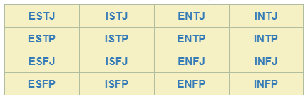

* (Optional) Encourage a friend or family member to take the same assessment to see how their results are similar or different.
* Consider—is there a way to incorporate your personality type on your *Tallo* profile? If you believe yes, do so now.
* What’s your Learning Style? (30 minutes)
* Complete this assessment: <http://www.educationplanner.org/students/self-assessments/learning-styles-quiz.shtml>
* Once finished, review your results. How does this help build your *Tallo* profile, but also help you better understand the way you best learn?
* Consider—is there a way to incorporate your learning style to your *Tallo* profile? If you believe yes, do so now.
* Find a personality quiz of your own to complete (30 minutes)
* Here is a link to a ton of BuzzFeed quizzes that are in categories for you to browse: <https://www.buzzfeed.com/quizzes>
* Select one that you find of interest and helps highlight your personality. Will you pick a quiz that identifies what Disney character you are, which Harry Potter house you belong to or what your superpower would be?
* Once finished, review the results and consider if this might be a fun piece to add to your *Tallo* profile. If you believe yes, do so now.
* Check-in with your Specialist. The indicator word is kiwi. (5 minutes)
  + Share with your Specialist what you thought of each of the five assessments.

Results How you added it to *Tallo*

* + 1. JAG Pre-Assessment
    2. True Colors Test
    3. Jung Typology Test
    4. What’s your Learning Style?
    5. YOUR CHOICE

* Take some time to update your *Tallo* profile with some or all of the results you discovered from this week’s exercises. (10 minutes)
* Specialist will record and share a link here or lead an in-person discussion with a wrap-up of this week’s exercises. The key will be to express the importance of assessments, surveys and quizzes to help us better understand what we are good at and interested in. Let students know that these type of quizzes are a good thing to do every year or so, as results shift over time. Encouraging students to take advantage of opportunities that are presented to them for assessments and/or seeking out experiences to participate in this type of ongoing learning is not only important, but can be a lot of fun! This may also be a good place for Specialists to share their results from the exercises.

Week 3 of 4

JAG Student Week Three Responsibilities

* **What do you want to be when you grow up?** Tough question; huh?! Maybe you know exactly what you want to do as your lifelong career or perhaps you have no idea. This week will help guide you through this process with some helpful tools. The results from this week’s Career Exploration exercise will be beneficial to adding to your *Tallo* profile so employers can connect with you about possible job opportunities!
* Watch this video: FREE Career Test by O*Net Interest Profiler (7 minutes)

<https://www.youtube.com/watch?v=vMDDdivsVvw>

* Complete the My Next Move Interest Profiler (30 minutes)
* Visit this link and follow the steps on the screen: <https://www.mynextmove.org/explore/ip>
* Once finished, write down your scores for the various categories.

|  |  |
| --- | --- |
|  | Score |
| Realistic |  |
| Investigative |  |
| Artistic |  |
| Social |  |
| Enterprising |  |
| Conventional |  |

* Check-in with your Specialist. The indicator word is movie. (2-5 minutes)
  + Share your scores from the My Next Move Interest Profiler. Have a discussion with your Specialist about two job zones that would be important for you to explore further.
  + Select one from these two options:
    1. Job Zone 1 – Little or no preparation needed (high school education is not required, typically a first job in retail/food service, manual labor, etc.)
    2. Job Zone 2 – Some preparation needed (high school graduation/GED required with previous work experience)
  + Select one from these three options:
    1. Job Zone 3 – Medium preparation needed (vocational on-the-job training, Associate’s degree)
    2. Job Zone 4 – High preparation needed (Bachelor’s degree or specialized training)
    3. Job Zone 5 – Extensive preparation needed (Graduate degree; i.e. Masters, Ph.D., etc.)
* Explore two Job Zones on My Next Move by checking out at least three jobs within each job zone that connects with your Interest Profiler results (30 minutes)
  + Job Zone #____
    1. Job ___________________________________________
       - Pros:
       - Cons:
    2. Job ___________________________________________
       - Pros:
       - Cons:
    3. Job ___________________________________________
       - Pros:
       - Cons:
  + Job Zone #____
    1. Job ___________________________________________
       - Pros:
       - Cons:
    2. Job ___________________________________________
       - Pros:
       - Cons:
    3. Job ___________________________________________
       - Pros:
       - Cons:
* Journal about what you found out about yourself this week. What surprised you about the career skills and/or interests you have? What job had you never heard of before seeing it in O*Net/My Next Move? Were you interested to learn about the job outlook/number of available jobs, salary and education levels for many popular careers that align with your interests? Was this exercise helpful for you? (15 minutes)
* Take some time to update your *Tallo* profile with some or all of the results you discovered from this week’s exercises. (10 minutes)

Week 4 of 4

JAG Student Week Four Responsibilities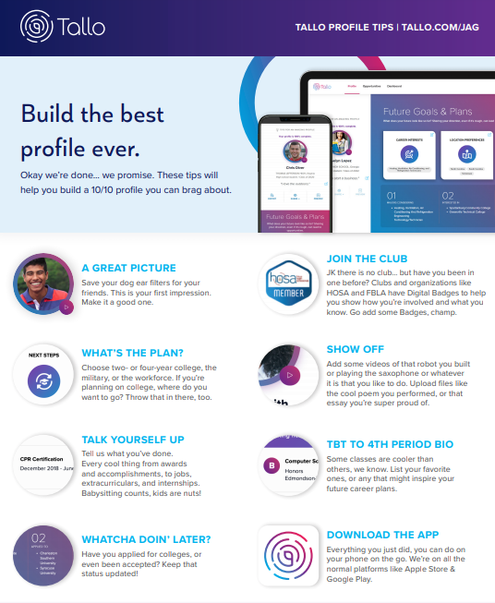

* Put the finishing touches on your *Tallo* profile (30 minutes)
* Upload a great profile picture
* Join more clubs/organizations and/or request additional badges
* Share your plan and goals
* Show off your skills
* (Optional) Download the FREE *Tallo* app
* Ask a friend or family member to review your *Tallo* profile. (10 minutes)
  + Ask for advice on the things you may have missed when creating your digital profile.
  + Make any necessary adjustments.
* Review the following websites for a double check of how to build a dynamic student profile on *Tallo*: (15 minutes)
  + Read - [https://*Tallo*.com/build-student-profile/](https://tallo.com/build-student-profile/)
  + Watch - [https://*Tallo*.com/learn-how-to-use-*Tallo*-videos/](https://tallo.com/learn-how-to-use-tallo-videos/)
* Check-in with your Specialist. The indicator word is computer science. (2-5 minutes)
  + Take a picture of your completed profile and share it with your JAG Specialist. Ask for their review of your content and see if they may have ideas for ways to improve.
  + Make any necessary adjustments.
* Remember the Driving Question for this Flex PBL: **How can I best showcase my talents, skills, experience and personality while also getting connected with opportunities specific to my goals through a digital profile on *Tallo*?** Begin to take all that you have learned through the various actions in this project to answer this question for yourself. Spend time writing in a journal, typing into a private blog and/or using a voice reminder recording as to whether you best highlighted your skills and interests on your newly developed *Tallo* profile and if you believe this tool can be used to connect you to opportunities. (20 minutes)
* Put together this project’s Public Product!
  + Express to others
    - 1) how you created and will maintain/update a dynamic digital profile and
    - 2) how you can assist others to do the same based on the tools you discovered during this project.
  + The mode of delivery is up to the student or group of students (verbal presentation, written communication and/or a visual representation).
  + Connect with your Specialist if you are wanting help with how or what to do for this project’s Public Product.
  + You may also refer to this link for the project rubric, which outlines the expectations: (insert rubric link here—remember you can find an example at the beginning of this document).
  + Before you are ready to present or perform your final piece to this project: a) walk through your Public Product idea for feedback from peers and b) practice.
  + If you lose motivation, remember this project also comes with pretty sweet incentives. In addition to access to employment opportunities and scholarships, JAG students are able to be entered into a drawing for one of four $250 eGift Cards to Amazon by simply creating a *Tallo* profile and request the **JAG 2020-2021 Membership** badge.
* Complete a JAG National student survey over this Flex PBL: <https://forms.gle/VtW3eQQw5BHo1sCW7>