MarieLynn’s Tavern

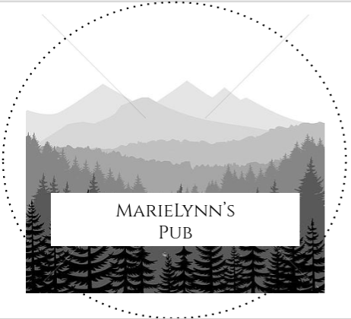

11 January 2019

[Marielynns.tavern@gmail.com](mailto:Marielynns.tavern@gmail.com)

**Table of Contents**

1. Executive Page Summary Page #1
2. Business Industry Review Page # 2
3. Sales and Marketing Plan Page #3
4. Financial Plan Page #4

**Executive Summary**

**Problem/Solution Lens:**

Madison is a small town and there is only 2 sit down restaurants. Also, neither of these restaurants serve alcoholic beverages. Many people in Madison drink their alcohol at home which makes it too easily accessible to children. By drinking in a public place where you get carded and cannot drive home drunk it limits the amount of drunk driving and children drinking if the parents do it responsibly in a public restaurant. If there were an alcohol serving restaurant in madison people would be less likely to drink at home. Also it might bring more people into madison if there were a nice restaurant with good food and drink. Although Madison does have few restaurant, they are focused on take-out and not sit-down dining.

**Value Proposition:**

Marielynn’s is a fun place in Madison, Maine that will provide good music, food, drinks, and dancing to all ages. There will be a safe place for adults to drink where they can get carded and a good source of entertainment for teenagers. It will provide a good non takeout restaurant. Marielynn’s has a modern sense of environment that will bring a new sense of style and look into Madison.

**Market Research**

According to Google Maps there are only 6 restaurants in Madison. Out of those 6 restaurants only 1 focusses on sit-down dining, the Lakewood Inn. “The other 5 are focused more on take out”. According to Bailey Brown Senior Madison Student. The Lakewood Inn is located by Lake Wesserunsett which is 13 miles from town. If we were to build MarieLynn’s Tavern, we would build in town 5 miles away at the most. This would make it easily accessible and possibly peoples first choice. It will bring in a majority from the Solon, Anson, and Madison area because of the lack of other dining restaurants that are in these towns. “Two out of three teens, aged 13-18, said it is easy to get alcohol from their homes without parents knowing about it.”

T, Buddy. “Do You Know Where Most Teens Get Alcohol From?” *Verywell Mind*, Dotdash, www.verywellmind.com/most-teens-get-alcohol-from-parents-friends-67012.

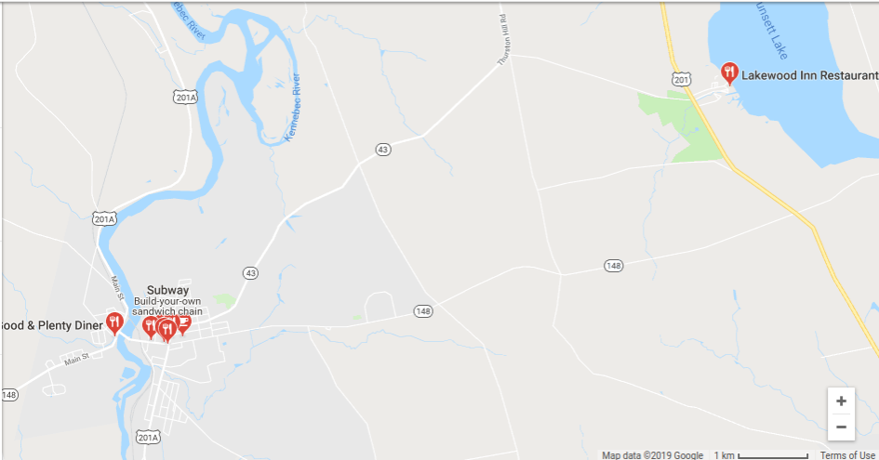

**Marketing Strategy**

Marilynn's strategy for marketing is to pay for advertisements to the Town of Madison and surrounding town to anyone that wants to wine and dine comfortably. We will also advertise to local colleges about the after 9 drinking and dancing hours. We will use social media like: facebook, Instagram, Spotify, maybe even make a documentary for Netflix. We will not use newspapers. This will hopefully bring in more of the younger generation but not excluding the older generation and people from out of town.

**Financial Plan**

The goal of MarieLynn’s is to be able to bring in 100 customers a night at least to bring in a profit of about $1000 per night.

This is the market of how much each and everything will be in order to get Marielynn’s up and running.

Building-$300,000 + 2 story addition=$150,000

Furniture-$30,000

Dining ware-$5,000

20 Employes- 30% of our gross sales

Marketing-$25,000

Computers-$5,000

Internet-$50 per month

Menus-$300

To go boxes-$300 a year

Signature drinks/foods- $4 to $9

Average meal $10

Parking Lot (3 acres paved)-$

Our plan is to buy 10 acres of land by Madison Electric and to clear out the trees and sell the logs to make a profit to cover the land that we had bought. We will then build our restaurant there. Our total cost is roughly $600,000 to $800,000.