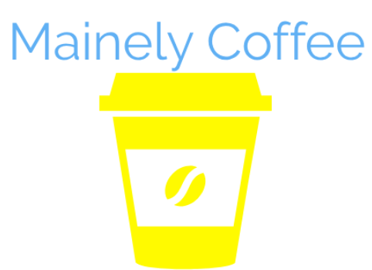

Mainely Coffee

January 10th, 2019

**Executive Summary:**

Mainely Coffee is an internet cafe offering locally brewed coffee, baked goods, study areas, tutoring services, and meeting spaces at an affordable price. Mainely Coffee solves the problem of the lack of safe and indoor spaces for teens, families, and businesses in Madison to meet and socialize. Because Mainely Coffee intends to serve Madison’s youth we will have Student Hour. Student hour is where we will have a specialized menu from 2pm-4pm everyday after school. All students have to do is show their student ID in order to receive the discount.

**Market Research:**

According to the U.S. Census in 2010, 19.2% of Somerset County’s population is under the age of 18. According to the Maine Integrated Youth Health Survey, among those who have drank alcohol in the past 30 days, the percentage who had 5 or more drinks was 54.9%. MIYHS states that 55.0% of students claim that they can buy or get marijuana “Sort of easy” and “Very easy”. Unlike Dunkin’ Donuts, we have a big space where people can lounge and socialize without having to pull up chairs or stand up. Mainely Coffee will offer the youth in our community better coffee, better baked goods, and a place to build relationships with one another. We will provide an alternative to drug and alcohol use by providing a safe place for young adults to spend time together. This would be very beneficial to our community because in Madison there is not very much to do.

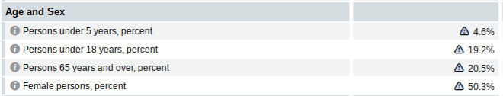

**Marketing Strategy:** Our company, Mainely Coffee, will help out our community by giving everyone a safe environment to hang out, by giving them coffee, baked goods and a lounge area. We can spread the word by advertisements, local businesses, by word of mouth, television, social media including Facebook and Instagram, and the radio.

**Financial Plan:**

Mainely Coffee will serve coffee, tea, specialty drinks, and baked goods only. We are going to partner with Madison’s local bakery to sell baked goods and we will use their price structure. Mainely Coffee will need $47,000 to start up. $15,000 will go to the down payment on a building. $10,000 will go to purchasing the machines we need to get started such as coffee makers and blenders, $10,000 will go toward buying furniture, signs and advertising and then the other $12,000 will go to paying the mortgage on our building. Our building is going to be $931 a month for 360 months with an interest rate of 4.45%. Sense we need to have internet we are going to go through Consolidated Communications to have our phone and internet bundle of $67.5 a month. To make this money we plan on fundraising for $25,000 of it and taking out a business loan on the other $22,000 of it. Because we want to have as many customers as possible and keep our products as affordable as we can our menu is this:

Coffee: Ice and Hot

Small Coffee $2

Medium $2.25

Large $2.50

Extra Large $3.00

Our flavorings include (which are free)

* Maple
* Pumpkin
* Caramel
* Blueberry
* Hazelnut
* French Vanilla
* Peppermint

Add ons to our drinks include free whipped cream, and espresso shot for $1

Mainely Coffee wants to partner with a different local coffee company every month to make a special flavor of the month. Not only will this help our company be creative, but hopefully their company will become more popular.

In order for us to make our money back we will need to make $130.5 a day for the first year in order to make back the original $47,000 we budgeted.