**Madison Extreme**

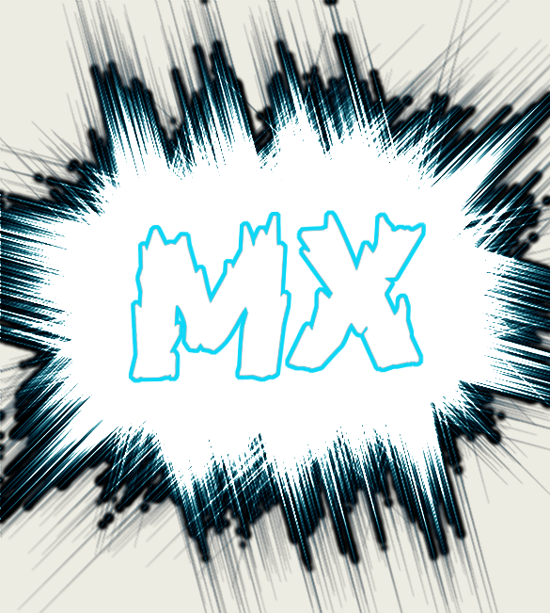

**January 8, 2019**

**Executive Summary**

**Problem / Solution Lens: What problem are you solving?**

In Madison, we struggle with widespread drug usage and not having enough to do for fun. Madison also struggles with unemployment from our mill shutting down and not enough job availability to younger people and the upcoming future of Madison. We are going to solve these problems by bringing in Madison Extreme, a family friendly fun park, with a lot to do and plenty of jobs to fill.

**Value Proposition: What does your company do? What solution do you offer?**

Madison Extreme is an indoor adventure park providing a variety of activities including paintball, bowling, trampolines, laser tag, and more at an affordable price. This will provide safe alternative activities in a healthy environment in an effort to decrease the percentage of teens using drugs and alcohol. We offer everything to people of all ages including a day care so parents do not have to worry about watching their kids and a beer garden for our older audience. In addition, we will be offering hundreds of job opportunities to young adults that will provide them with the skills they need for the real world, such as money management, in an effort to bring business back to Madison and boost our community’s economy.

**Market Research**

**Summary of Research:**

The main goals of Madison Extreme are to provide jobs and to provide a safe, alternative place for teenagers to spend their free time. The unemployment rate in Somerset Country is the highest in the entire state of Maine (4.4%). Our business will provide hundreds of jobs that will help to lower that rate. According to the United States Census Bureau, Maine’s population has grown less than 1% over the past 8 years and Somerset County’s population has decreased by 3%. Since Madison Extreme will provide more jobs, it will make that percentage grow as well. Madison Extreme will also cater to teens struggling with drugs, alcohol, and depression. The 2017 MIYHS High School Report taken from Madison Area Memorial High School states that 55% of Madison students reported it being “sort of easy” or “very easy” to get marijuana, and 19.9% of students reported using marijuana at least once during the past 30 days. Also, among students who reported drinking alcohol in the past 30 days, 54.9% reported having 5 or more drinks at a time, and 60.6% of students reported it being “sort of easy” or “very easy” to get alcohol. 26.4% of Madison students reported feeling so sad or hopeless almost every day for two weeks or more in a row that they stopped doing some usual activities. Our goal for Madison Extreme is to help lower these numbers by giving teenagers a safe place to have fun and enjoy life. The town of Madison is in desperate need for a business like ours to combat unemployment and help teens stay out of trouble.

**Competitors:**

In Madison, the industry offers very little to compete with our new business. There is Roy’s Inflatable Waterslide Park, which is a seasonal outside waterpark with an ice cream stand attached. We are new and better because we are open all year round, cheaper overall, safer, better employed, and have more activities to offer. In Skowhegan, there is a bowling alley that has an arcade and a bar, but again we offer more for lower prices.

**Marketing Strategy**

**Customers & Relationships: Who are you helping and how do you interact?**

We plan on sectioning off our building so each section can cater to a specific audience. Our main activities and our tutoring center will target middle and high school students. Along with the tutoring service, we will hire high school students to teach technology classes aimed toward older adults and the elderly. By having a child care service, we also target young parents. We will also section off an area for people 21 and over and that is where our beer garden will be. Our bartenders will be trained to cut people off after they have reached their limit to encourage responsible drinking. We will also have a security guard to make sure no one drives away drunk. We will specifically hire drivers to drive people home from the bar if need be. We will interact with our customers through our social media pages, our own personal website, online reviews, and in-person top of the line customer service.

**Channels: How will you reach your audience and spread the word?**

We plan to spread the word of our business through Facebook, Instagram, our own website, Google Ads, word of mouth, commercials, flyers, and other basic advertisements. Facebook offers business pages that we will take full advantage of to then direct people to our website. We will have an Instagram page as well and pay for Instagram ads. Our website will have all of the information of what we offer, prices, hours, our staff, and more.

**Financial Plan**

**Revenue Stream:** We will make money by selling tickets for all of our activities and depending on the activities, renting equipment. We will have a snack bar that will feature products from local businesses that will have to pay us to sell their products. We will have a daycare and beer garden to appease older crowds and bring in more income. Our cover charge will be $10. We will charge $2-30 for food and drinks. Our menu would consist of hamburgers and cheeseburgers for $3.50 and $4, fries for $2, fountain drinks for $1, cheese sticks for $3, etc. Tickets will have prices by the hour or day and we will offer season passes. Go-karting will be $10 an hour, bowling at $5 an hour, day care is $20 for the whole day, laser tag is $10 an hour, paintball is $10 an hour, and all of these come with certain deals like bundles or if someone will be spending many hours they can get a discount. The prices for tutoring and other calles will depend on the subject and amount of time needed but will range from $5-$15 per hour. We will also offer credit cards for customers to save rewards and get money off. We will charge local businesses $500 a month for any type of advertising. We will be open from 10am to 10pm with special nights and deals on various weekends.

**Cost Structure:**

**Land-** 117 Blackwell Hill Road: $37,500

**Construction-** $200,000

**Utilities-** $3,000

**Go Karts-** $37,000

**Paintball-** $5,712

**Trampolines-** $50,000

**Laser Tag-** $3,000

**Employees-** $3,432

**Marketing-** $2,000

**Total Cost - $341,644**

If we have 50 customers a day that only pay the cover charge, we will make our money back in two years. However, we anticipate making it back sooner because people will spend more money on things other than just the cover charge.

**Funding Strategies:**  We will obtain start-up funds primarily by obtaining corporate sponsors like New Balance and Coca-Cola for example. We will also have local businesses donate products and resources to us, and we will give them discounts and advertise their businesses at Madison Extreme in return.

**Potential Partners:** New Balance, Sugarloaf, Nike, Coca-Cola, Local Small Business, Local Breweries, Madison Area Memorial High School