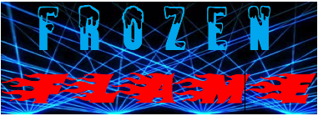

Created January 10, 2019

Executive Summary

Frozen Flame is a laser tag, airsoft, and paintball center for young adults in Madison, ME. Currently, there is a lack of physical activity and recreational opportunities in our town for teens. We will provide these youth a variety of activities at an affordable rate in order to increase physical activity while having an amazing time.

Market Research

In a survey done in 2018 it showed of Madison High School students that out of 34 people about 79% would participate on an airsoft field. In the same survey out of 36 people about 89% said they would participate on an paintball field. 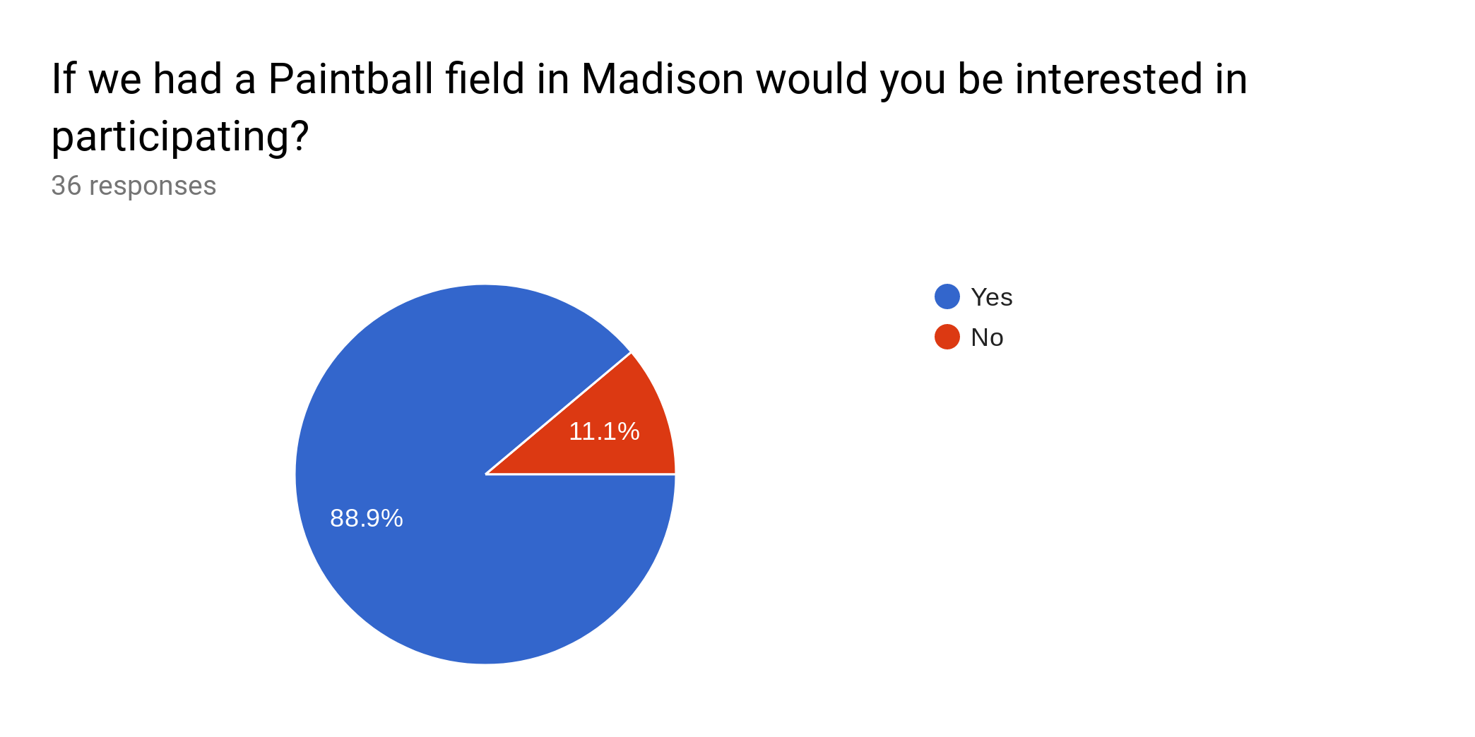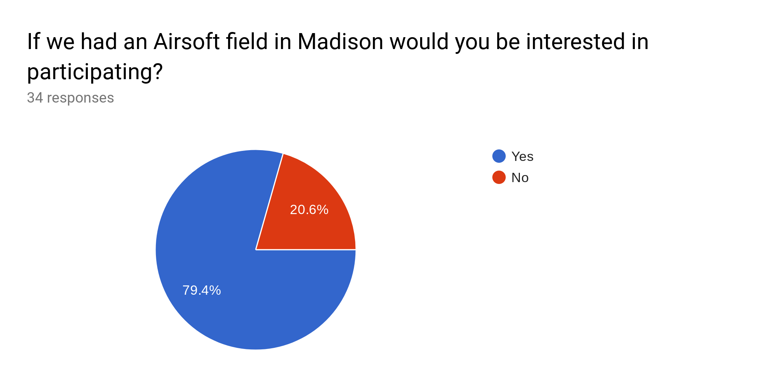

This company is needed because exactly 22.8% of high school in Madison are overweight according to the Maine Integrated Youth Health Survey. In addition, only 19.4% of students are physically active for 60 minutes or more daily, according to the same survey. This shows that more physical options would be good for the town of Madison.

Marketing Strategy

Our audience mainly consists of teens in local and surrounding communities. We would using a Facebook page and Instagram as well as newspaper ads, printed flyers, and TV commercials as a way of communicating our business.

Financial Plan

We would make revenue through having a monthly membership people can pay for $40 monthly, that includes discounts on rentals that would be $40, snacks, drinks. We would also be selling snacks, drinks, and merchandise in the main building for when customers are hungry and thirsty. We would also have tournaments for high school and college students and between businesses such as Hannaford and Walmart for charity donations. An hourly rate for a large party $100.

Cost Structure:

Employees - $8,800 per month x 12= $105,600

Computers - $1,500

Electricity - $160 per month x 12= $1,920

Oil to heat the building in the winter - $1,215 per month x 12= $14,580

Security Cameras - $1,000

Airsoft, Paintball, Laser Tag Gear - $5,000

Internet - $36.70 per month x 12= $440.4

Insurance - $41.66 per month x 12= $499.92

Land - $100,000

Food Truck: Snack Bar - $250

NewsPaper Advert - $480

TV Advert - $3,113 per month x 12 = $37,356

Total for first year: $268,626.32

Hours/Seasons - Open during the spring, summer, and fall. We would be open on the weekends during the school year at noon to 6/8 at night. The summer we may open earlier from maybe 11:30 till around 9 at night.

We could obtain funds by applying for a business loan, attempt a corporate sponsorship, and start a GoFundMe page. Potential partners we could obtain are Pepsi, Coca Cola, Redbull. Some partners for the equipment for airsoft could Tokyo Marui, Classic Army, and CYMA where we would rent out their equipment and even possibly become a distributor for them. Local business to partner could be Subway, Snack Shack, Pizzarama, Al’s Pizza.

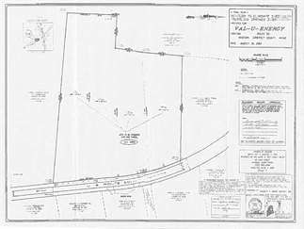

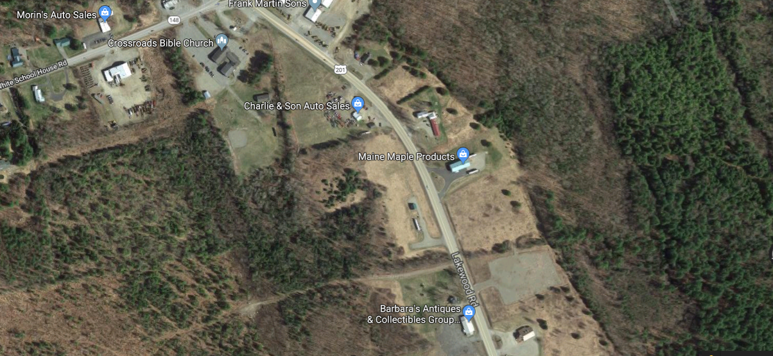

* Future location of Frozen Flame
* Route 201, Madison ME