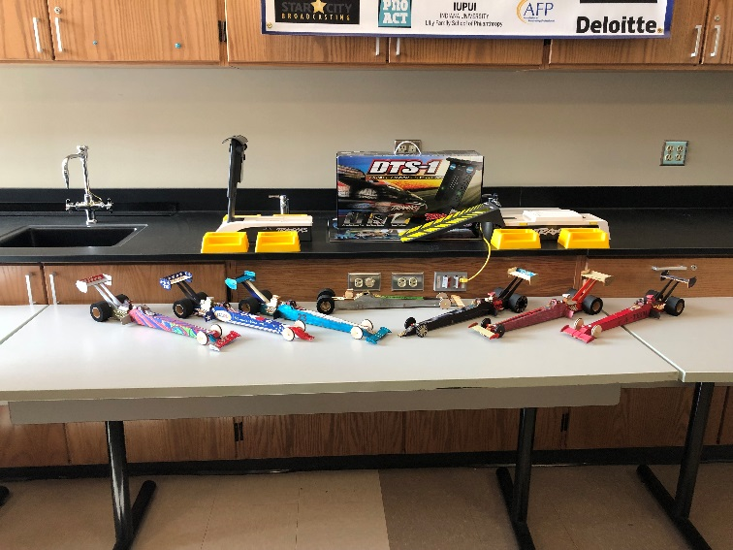Eight Teams competed building and running “Nitro” Top Fuel Dragsters from <https://aeroracers.com/product-category/home/products/gadd-dragsters>

We used the promo code NHRA to save.

Purchased separately, each car is about $34.99 and included all materials needed for the cars.

This video shows how the cars are powered and raced: <https://youtu.be/DaSazHC_sHI>

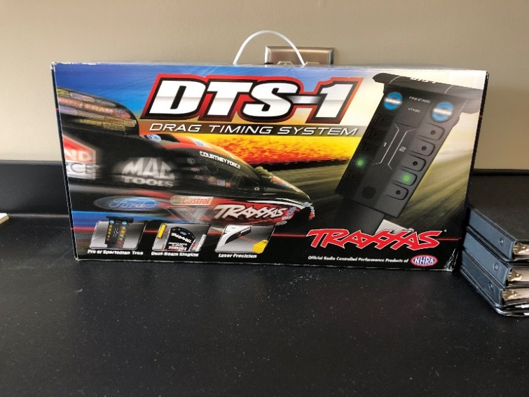

Though an optional item, a sophisticated timing system was purchased using funds that were fundraised by the students.

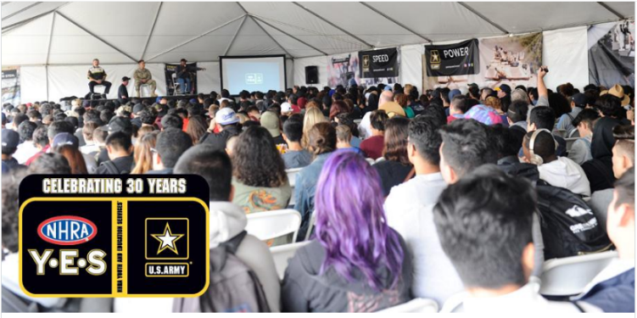The entry event was held at the Indianapolis Raceway in Speedway where the NHRA and US Army hold a partnership every year discussing careers in the motor sports industry. Students listen to a 15 minute presentation, then visit booths (and watch racing) designed to share the appeal of careers both in the military and in motorsports.

This link shows the 2018 season: <https://www.nhra.com/news/2017/nhra-youth-and-education-program-will-celebrate-30th-season-2018>